How to add offline donations to your JustGiving page
There are two ways to make sure offline donations reach the charity.
- Make an online donation using your own credit/debit card
Pay the donations into your own bank account and make an online donation via your JustGiving page. If you choose this option and are a UK taxpayer make sure that you un-tick the Gift Aid box. Gift Aid should only be claimed when an eligible donor is making their own donation, not on behalf of someone else or a group.

Send donations to the charity directly and use the 'Raised offline' function
You can also send donations raised offline directly to the charity. It's a good idea to reference your JustGiving page address to help with their reports.
If you are a UK taxpayer and your donations are eligible for Gift Aid, you can use sponsorship forms to collect the details of those that are eligible for Gift Aid and send it to the charity along with the donations.
Add these donations as a 'Raised Offline' amount so they're included in your fundraising total. Here's how:
- Log into your account
- Click 'Edit' on the page you'd like to add the balance to from your profile area
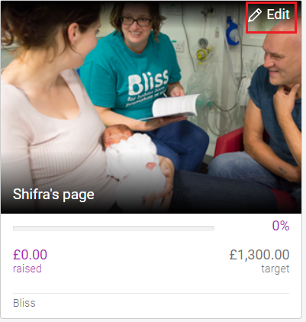

3. Click 'Donations' along the top of the page
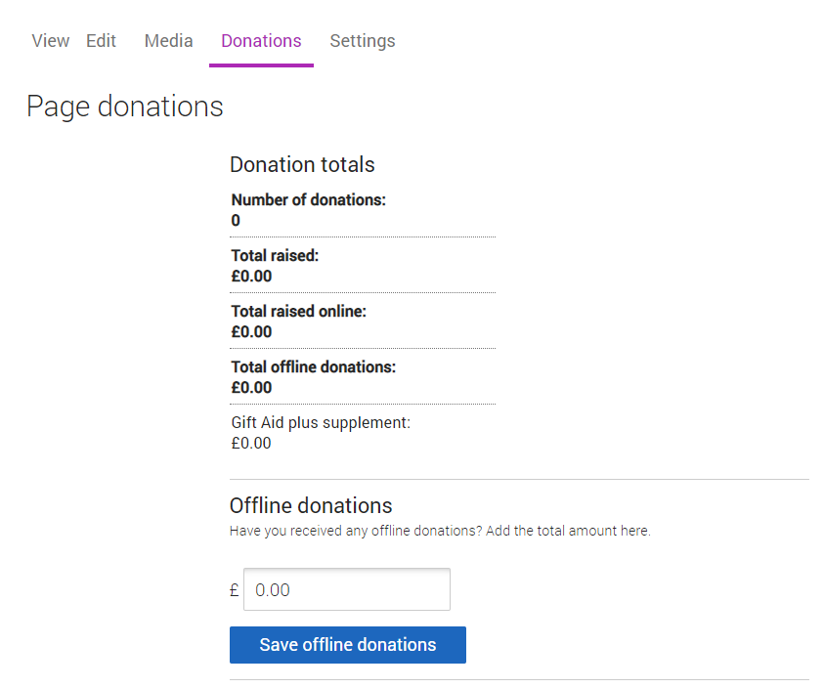

4. Amend the total amount raised offline and select 'Save offline donations'.
If you’d like to acknowledge the friends and family who've given you money offline, you can add a quick update to your page thanking them for their donation.

